Camera.

- My camera is a 4.0 megapixel digital camera.
- I take pics for slides with the following settings:
- Image Size: 2272x1708
- Quality: 1600x1200/Fine.
- I always shoot my image with a flash and without, to compare afterwards.
- I always use a tripod.
- I try and take my shots dead on, without any angles, particularly with flat work against a wall. With sculptural/3D objects you have more freedom.

Photoshop.

- Open image and work on it in any direction, but be sure that when it’s ready to go, you have it tilted to landscape.

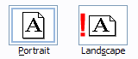

- The most common complaints about slides is being too dark. Make sure they’re bright. They’ll be projected and enlarged when looked at, so they need to be bright enough to withstand those factors.
  - Check levels.
Image>Adjustments>Auto Levels
[If this looks bad, undo]
  - Check color.
Image>Adjustments>Auto Color.
[If this looks bad, undo]
  - Manually adjust levels.
Image>Adjustments>Levels

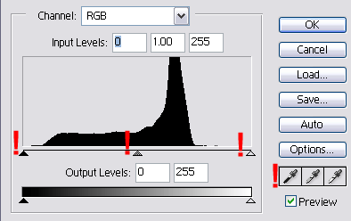

The first step is to use the droppers on the right. Begin with the far right one (Light tones). Click on it, and then fine a spot on your image that looks like one of the lightest areas. Then click your dropper.
  - If this doesn’t work, try using the sliders to the left. Each arrow corresponds to the droppers. (Light, Midtone, Dark).
  - If that does work, then adjust the midtones slider.

*My rule of thumb is: Once it looks light enough, I always lighten a little more.

  - Manually adjust colors. [Note I only do this if something looks too blue, yellow whatever.]
Image>Adjustments>Color Balance

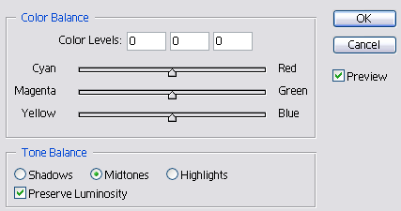

This is where my artistic instincts kick in. I just experiment. Too much yellow in my image=I adjust the Blue, and vice versa. My photography knowledge isn’t sophisticated enough to know what the rules are, so I just experiment.

*My rules of thumb is: If I can’t get the colors to look right, I re-shoot the image.

  - Resize the image. This is the part that everyone differs about. But I will say this: My images always come out clear, crisp and fill the entire slide. I never have a smaller image floating on a black field (which some people have found with their smaller images). I have also been told by lab techs last year that DPI isn’t as important as the image size. Some people say they prepare their image with a high DPI (600) as well as Image Size. I have always prepared mine with a 72 DPI.

This image shows the specs that should be entered before your resize your
image. Once you have done that, choose the crop tool and drag from the top
left side of your image down to the bottom right corner.
Crop Tool:

*Sometimes, when you do this, the crop tool will not hold the whole image:

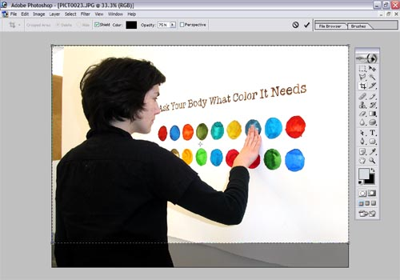

In which case you do as follows:

- Continue to drag the crop beyond the image size.
You will end up with dead space on one side of the image.

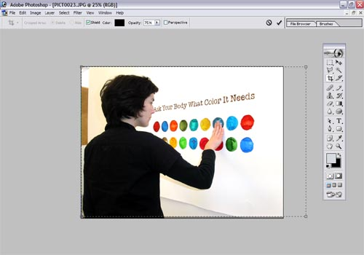

- Use your arrow keys to move this crop space until you have an even space on either side of the image.

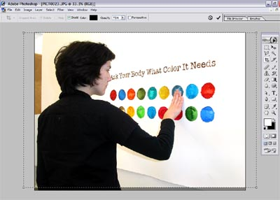

- The end result should look like this:

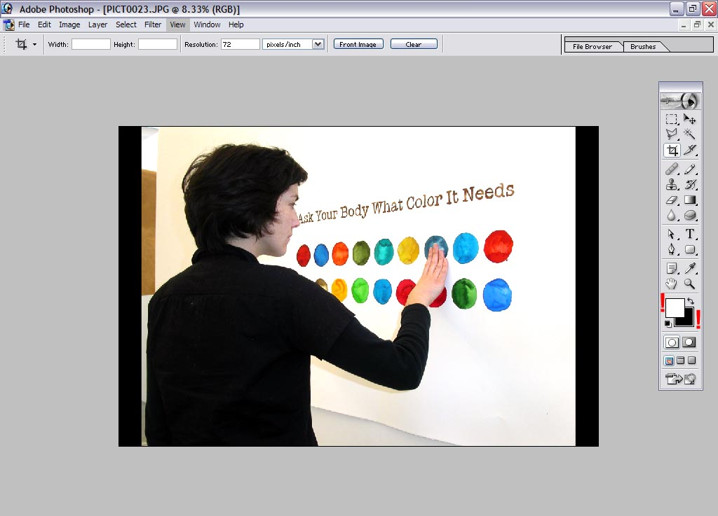

*Note: The colors you have selected on the tool bar, will determine what color your outer border will be when you do this type of crop. A good rule of thumb is either black or white.

  - Save your image. The file will be big, so you may have to wait a few seconds. I always save my files as a TIFF, because there is the least amount of compression. A JPEG would work too.

  - At this point, you need to transfer your images to the computer that has the slide machine. I always burn them to disc, as it’s quicker than transferring from an external hard drive. Because the images are so big, I can usually only fit 4-5 images per disc.

Slide Film.

I only use Provia 100, so I can only speak for that. I have heard that Astia film sometimes results in flat or yellowed slides.

Slide Machine.

- Follow all the necessary steps to open RasterPlus on the computer. These are taped to the wall, above the computer.
- Put disc in computer.
- Make a folder on the desktop with your name.
- Drag the images from your disc into the folder. This should take a few minutes. If you have multiple discs, follow these steps until all images are in your folder.
- Open RasterPlus.
- Drag the image files in your folder to the gray RasterPlus window.
- You now have each image, with a quantity of 1.
- If you do not have 36 images, I suggest creating more than 1 of each slide. You can do this by clicking on the up arrow next to each image. The numbers will increase. The Provia slide film only comes in roles of 36, so you might as well make dupes now.
- At this point, load your film into the machine. Open the top flap, and you will see small black camera. Open the back of the camera, like you would any other camera.
- DO NOT TOUCH THE BLACK LEVER NEXT TO THE CAMERA!! This can dismantle the camera from the machine, which lets light in and that will ruin your film.
- Take your roll of film, and slot it into the camera, nipple facing down. Pull the flap of film over to the right side, until it slots in under the film icon on the right. The flap of film should now be retracting into the camera.
- Close the camera. You should hear it loading the film, as well as see the display reading something to the effect of ‘film loading’.
- What is happening at this point: The camera is winding your film to the end of the role. It starts the burning process at frame #36, and works its way backwards, until it’s back at frame #1. [This is why people who don’t burn 36 slides have problems: The machine will stop when images are done burning, but the role isn’t back at frame #1. If you end up in that situation, there is a menu/buttons of options on the actual machine, and you will need to figure out how to rewind the film. I have never done this, so I can’t advise how]
- You are now ready to burn your slides. Click the green PLAY icon in RasterPlus.
- A full roll takes 2.5 – 3 hours for completion.
- Make a note and leave it on the keyboard. It’s always good to leave your number, in case the machine stops working or there’s a problem – someone can call you and let you know.

